Assignment-2

PROJECT NAME | CUSTOMER CARE REGISTRY
NAME | R.SATHIKUMAR
ROLL NO | 620619104032
Team id | PNTN2022TMID41464

Create User table with user with email,username,roll number, password.

Program:

from tkinter import*

from tkinter import*

root = Tk()

root.geometry('500x500')

root.title("Registration Form")

label_0 = Label(root, text="Registration form",width=20,font=("bold", 20))

label_0.place(x=90,y=53)

label_1 = Label(root, text="FullName",width=20,font=("bold", 10))

label_1.place(x=80,y=130)

entry_1 = Entry(root)

entry_1.place(x=240,y=130)

label_2 = Label(root, text="Email",width=20,font=("bold", 10))

label_2.place(x=68,y=180)

entry_2 = Entry(root)

entry_2.place(x=240,y=180)

label_3 = Label(root, text="Gender",width=20,font=("bold", 10))

label_3.place(x=70,y=230)

var = IntVar()

Radiobutton(root, text="Male",padx = 5, variable=var, value=1).place(x=235,y=230)

Radiobutton(root, text="Female",padx = 20, variable=var, value=2).place(x=290,y=230)

label_4 = Label(root, text="Age:",width=20,font=("bold", 10))

label_4.place(x=70,y=280)

entry_2 = Entry(root)

entry_2.place(x=240,y=280)

Button(root, text='Submit',width=20,bg='brown',fg='white').place(x=180,y=380)

from tkinter import*

root = Tk()

root.geometry('500x500')

root.title("Registration Form")

label_0 = Label(root, text="Registration form",width=20,font=("bold", 20))

label_0.place(x=90,y=53)

label_1 = Label(root, text="FullName",width=20,font=("bold", 10))

label_1.place(x=80,y=130)

entry_1 = Entry(root)

entry_1.place(x=240,y=130)

label_2 = Label(root, text="Email",width=20,font=("bold", 10))

label_2.place(x=68,y=180)

entry_2 = Entry(root)

entry_2.place(x=240,y=180)

label_3 = Label(root, text="Gender",width=20,font=("bold", 10))

label_3.place(x=70,y=230)

var = IntVar()

Radiobutton(root, text="Male",padx = 5, variable=var, value=1).place(x=235,y=230)

Radiobutton(root, text="Female",padx = 20, variable=var, value=2).place(x=290,y=230)

label_4 = Label(root, text="Age:",width=20,font=("bold", 10))

label_4.place(x=70,y=280)

entry_2 = Entry(root)

entry_2.place(x=240,y=280)

Button(root, text='Submit',width=20,bg='brown',fg='white').place(x=180,y=380)

# it is use for display the registration form on the window

root.mainloop()

print("registration form seccussfully created...")

Output:
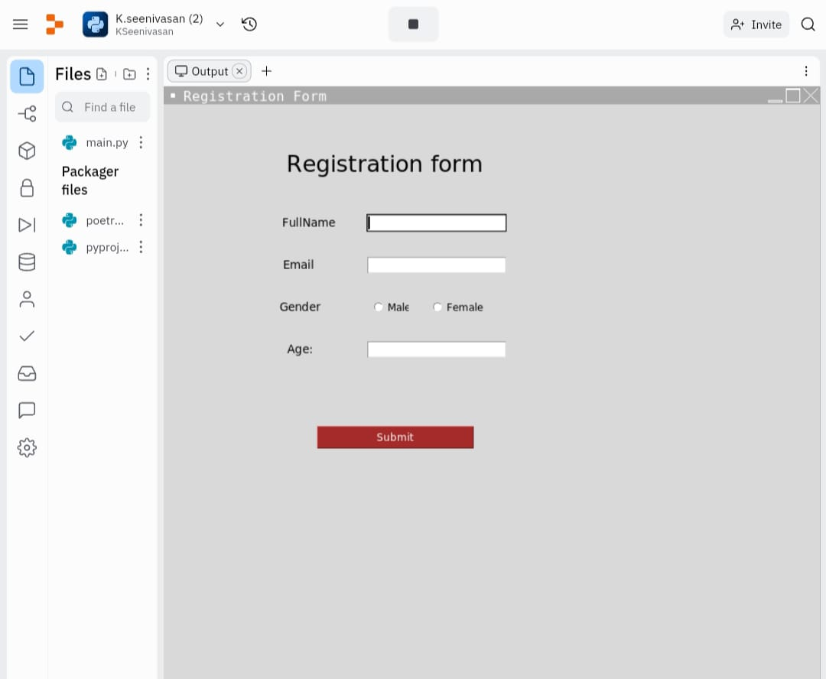
2.Perform UPDATE ,DELET Queries with user table

Program:

from tabulate import tabulate
print(tabulate({'First Name':
['SEENIVASAN', 'SRIRAM','SATHIS KUMAR','THIRUMALAI'],
'Last Name': [ 'K', 'T', 'R' ,'M'],
'ROLL NO': [620619104034, 620619104035, 620619104035 ,620619104039]},
headers="keys", tablefmt='fancy_grid', missingval='N/A'))

Output:

